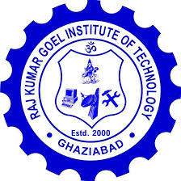
Raj Kumar Goel Institute of Technology Ghaziabad
ISO 9001:2015 Certified
5th KM. STONE, DELHI-MEERUT ROAD, GHAZIABAD (U.P)-201003
Tel: (0120) 2788409, Fax: (0120) 2788447

Department of Computer Science & Engineering
Mid term Project Presentation -1 (IP-1) 2023-24 Date of Presentation:

Group No. : G-2

Title of project: …………………………………………….…………………………….

Name of Team Leader: ………………………………………………………………….

Name of Project Guide: …………………………………………………………………

Details of Group members:

S. No. | Roll No. | Name
 | 200033010084 | Chirag Singhal
 | 200033010069 | Ashutosh Maurya
Project Evaluation
Evaluation Criteria | MM (20 ) | Marks Obtained
Evaluation Criteria | MM (20 ) | Student-1 | Student-2 | Student-3 | Student-4
Viva Voce/ Presentation | 20
Project Implementation /Testing | 20
Coordination Among Students | 10
Status of Project | 10
Total Marks | 60
V. Good(17-20) Good (13-16) Average (9-12) Below Average (0-8)

Name & Signature of Committee member-1

Name & Signature of Committee members-2

Name & Signature of Project Coordinator : Devesh Garg

